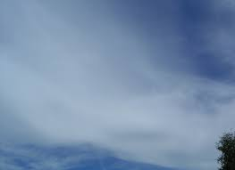  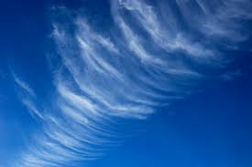  Cirrus: High, thin, wispy | Cirrostratus: High, thin, light gray or white that cover sky | 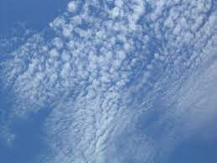  Cirrocumulus: High, puffy, wave-like patterns | 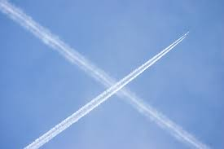  Contrails: High, formed by planes
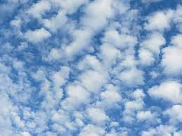  Altocumulus: Mid level puffy | 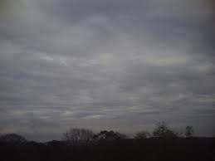  Altostratus: Mid level, light gray and uniform | 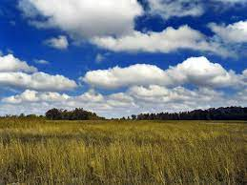  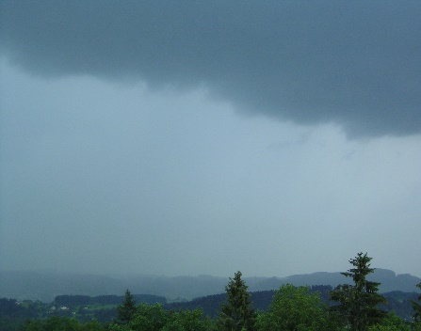  Nimbostratus: Low and middle dark gray, precipitation | Cumulus: Low, puffy, like cotton balls
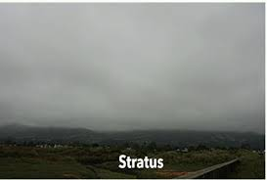  Stratus: Low, uniform light gray | 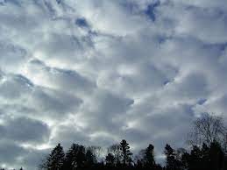  Stratocumulus: Low, rolling or puffy | 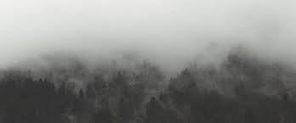  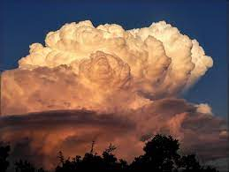  Cumulonimbus: Low, large, dark base, anvil shape | Fog: Low, light gray with low visibility

